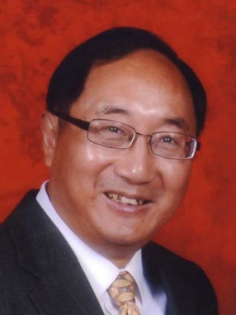

Xian-He Sun

Illinois Institute of Technology

Chicago, USA

Date: May 21, 2024

Time: 10:00 ~ 12:00

Location: 階梯教室4263

Addressing Data Tsunami: An I/O System Approach under the von Neumann Machine

## Abstract

--------

*Big data, AI, and other data-driven applications generate massive amounts of data and create new data-discovery demands. These applications have fundamentally transformed the computing landscape, making it increasingly data-centric and data-driven. However, the performance improvement of disk-based storage systems has lagged that of computing and memory, resulting in a significant I/O performance gap. Simultaneously, data discovery necessitates new forms of data, further straining existing memory and storage systems. In this talk, we first address the challenges and solutions related to I/O systems for high-performance computing (HPC). To illustrate the state of the art of HPC I/O systems, we showcase Hermes, an intelligent, multi-tiered, dynamic, and distributed I/O buffering system. Hermes has been released as open source under the widely used HDF5 library and has demonstrated its high performance power in HPC practice. We then delve into the new difficulties and potential solutions for managing new kinds of data, such active data, metadata, inference data, under new environments, such as workflow and cloud. Finally, we will discuss the general issue of data-centric system designs and present our thoughts on computer system design in the era of AI and big data.*

**Bio-Short version**

Dr. **Xian-He Sun** is a University Distinguished Professor, the Ron Hochsprung Endowed Chair of Computer Science, and the director of the Gnosis Research Center for accelerating data-driven discovery at the Illinois Institute of Technology (Illinois Tech). Before joining Illinois Tech, he worked at DoE Ames National Laboratory, at ICASE, NASA Langley Research Center, at Louisiana State University, Baton Rouge, and was an ASEE fellow at Navy Research Laboratories. Dr. Sun is an IEEE fellow and is known for his memory-bounded speedup model, also called Sun-Ni’s Law, for scalable computing. His research interests include high-performance data processing, memory and I/O systems, and performance evaluation and optimization. He has over 300 publications and 7 patents in these areas and is currently leading multiple large software development projects in HPC I/O systems. Dr. Sun is the Editor-in-Chief of the IEEE Transactions on Parallel and Distributed Systems, and a former department chair of the Computer Science Department at Illinois Tech. He received the Golden Core award from IEEE CS society in 2017, the ACM Karsten Schwan Best Paper Award from ACM HPDC in 2019, the Ron Hocksprung Endowed Chair from Illinois Tech in 2020, and the first prize best paper award from ACM/IEEE CCGrid in 2021. More information about Dr. Sun can be found at his web site [www.cs.iit.edu/~sun/](http://www.cs.iit.edu/~sun/).